**Class Name & Stats**

|  |  |  |  |  |  |
| --- | --- | --- | --- | --- | --- |
| **Illuminator** | | | | | |
| **Canon Name: Adam** | | | | | |
| **Base stats** | | | | | |
| **Resolve** | **1** | **2** | **3** | **4** | **5** |
| **Max HP** | **30** | **36** | **42** | **48** | **54** |
| **Dodge** | **0** | **5** | **10** | **15** | **20** |
| **Prot** | **0%** | **0%** | **0%** | **0%** | **0%** |
| **Speed** | **4** | **4** | **5** | **5** | **6** |
| **Crit** | **5%** | **6%** | **7%** | **8%** | **9%** |
| **Dmg** | **6-10** | **7-12** | **8-14** | **9-16** | **10-18** |
| **Resistances** | | | | | |
| **Stun** | | **40%** | **Move** | | **30%** |
| **Blight** | | **30%** | **Bleed** | | **60%** |
| **Disease** | | **50%** | **Debuff** | | **30%** |
| **Death Blow** | | **67%** | **Trap** | | **10%** |
| **Other Information** | | | | | |
| **Movement** | | 1 forward, 1 backward | | | |
| **Crit Effect Bonus** | | Heal 10% max hp | | | |
| **Religious** | | Religious | | | |
| **Provisions** | | Prayer Candle  (+10 light, +10% Prot, -10% stress, -10% crits received for one battle) | | | |

**Ancestor Quote**

"Covered in the Will of the Flame... This golem will stop at nothing to quell the evil from the dungeon."

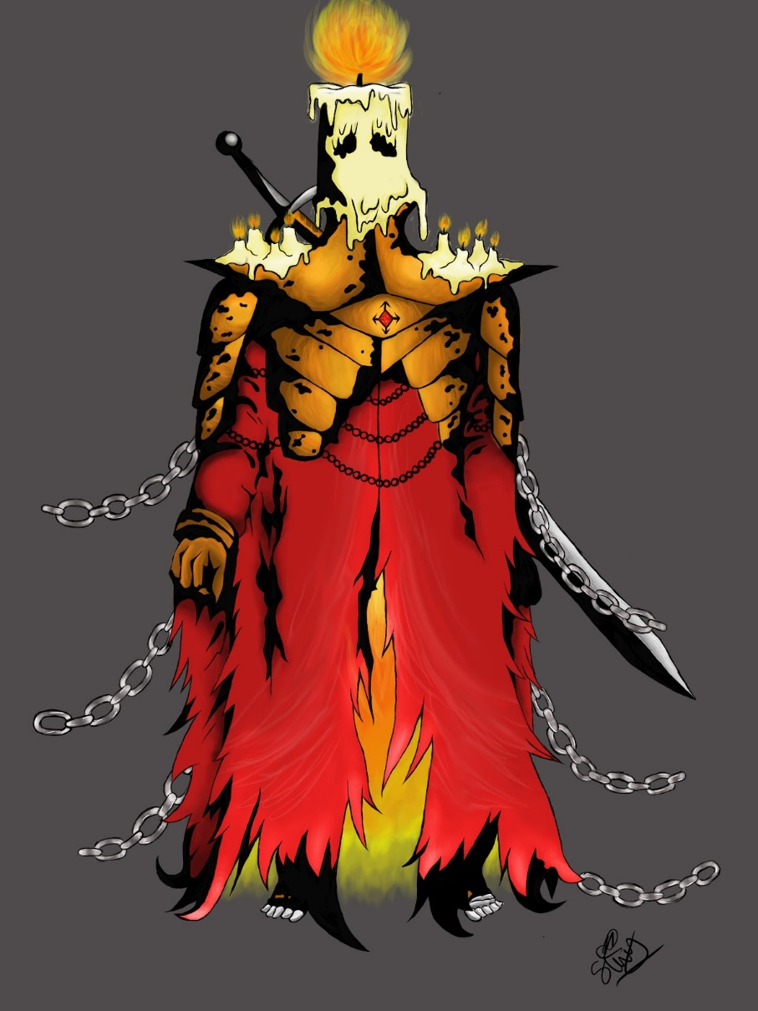

Art by @FireNeko/Azar on discord

|  |
| --- |
| Class description:  *"It was only granted life because of a martyr of the highest order among the Holy Flame, who gave their life for its creation.*" |

**Overview:**

The illuminator is a mid to frontline warrior/support. Some of his moves are powerful but melt his hp in higher amounts of light while others do different things depending on the light level. Calling upon the light he can use a powerful & cleansing self heal at the cost of stunning himself. When camping he can comfort the party and himself as well as produce more Prayer Candles that buff a singular hero for a battle.

Class Skills

|  |  |  |  |  |  |  |
| --- | --- | --- | --- | --- | --- | --- |
| **Sever Shadows** | | | | | | |
| **Range** | **Rank** | **Target** | **DMG** | **ACC** | **Crit Mod** | **Effect** |
| **Melee** | **○○●●** | **●●○○** | **0%** | **80** | **4%** | **3 self DMG (Scales to 0 in dark) Torch +5**  **+4% dmg per 25 light**  **+3 acc per 25 darkness Bypass stealth/Destealth** |
| **Further Levels** | | | | | | |
| **Level 2** | | | **0%** | **85** | **5%** | **4 self DMG (Scales to 0 in dark)**  **Torch +5**  **+4% dmg per 25 light**  **+3 acc per 25 darkness**  **Bypass stealth/Destealth** |
| **Level 3** | | | **0%** | **90** | **6%** | **4 self DMG (Scales to 0 in dark)**  **Torch +5**  **+5% dmg per 25 light**  **+4 acc per 25 darkness**  **Bypass stealth/Destealth** |
| **Level 4** | | | **0%** | **95** | **7%** | **5 self DMG (Scales to 0 in dark)**  **Torch +5**  **+5% dmg per 25 light**  **+4 acc per 25 darkness**  **Bypass stealth/Destealth** |
| **Level 5** | | | **0%** | **100** | **8%** | **5 self DMG (Scales to 0 in dark)**  **Torch +5**  **+6% dmg per 25 light**  **+5 acc per 25 darkness**  **Bypass stealth/Destealth** |

|  |  |  |  |  |  |  |
| --- | --- | --- | --- | --- | --- | --- |
| **Empyrean Halo** | | | | | | |
| **Range** | **Rank** | **Target** | **DMG** | **ACC** | **Crit Mod** | **Effect** |
| **Ranged** | **○●●○** | **●●●●** | **-80%** | **95** | **6%** | **Bypass stealth +2% Crit chance per 25 Light +10% debuff chance per 25 Dark**  **Debuff: -10% stun resist +8% crit recieved  (100% chance)** |
| **Further Levels** | | | | | | |
| **Level 2** | | | **-80%** | **100** | **7%** | **Bypass stealth +3% Crit chance per 25 Light**  **+10% debuff chance per 25 Dark**  **Debuff: -15% stun resist +8% crit recieved  (110% chance)** |
| **Level 3** | | | **-80%** | **105** | **8%** | **Bypass stealth +4% Crit chance per 25 Light**  **+10% debuff chance per 25 Dark**  **Debuff: -15% stun resist/ +9% crit recieved  (120% chance)** |
| **Level 4** | | | **-80%** | **110** | **9%** | **Bypass stealth +5% Crit chance per 25 Light**  **+10% debuff chance per 25 Dark**  **Debuff: -20% stun resist +9% crit recieved  (130% chance)** |
| **Level 5** | | | **-80%** | **115** | **10%** | **Bypass stealth**  **+6% Crit chance per 25 Light**  **+10% debuff chance per 25 Dark**  **Debuff: -20% stun resist +10% crit recieved  (140% chance)** |

|  |  |  |  |  |  |  |
| --- | --- | --- | --- | --- | --- | --- |
| **Pilgrim’s March** | | | | | | |
| **Range** | **Rank** | **Target** | **DMG** | **Acc** | **Crit** | **Self** |
| **Melee** | **●●●○** | **●-●○○** | **-60%** | **85** | **-7%** | **Forward 1**  **4 self DMG (Scales to 0 in dark) Dmg Reflect 25/40% in 51/76 Torch +10 torch between 76/25 light +2/4 speed in 50/25 Dark** |
| **Further Levels** | | | | | | |
| **Level 2** | | | **-60%** | **90** | **-6%** | **Forward 1**  **6 self DMG (Scales to 0 in dark) Dmg Reflect 30/45% in 51/76 Torch +10 torch between 76/25 light +2/4 speed in 50/25 Dark** |
| **Level 3** | | | **-60%** | **95** | **-5%** | **Forward 1**  **6 self DMG (Scales to 0 in dark) Dmg Reflect 35/50% in 51/76 Torch +10 torch between 76/25 light +3/6 speed in 50/25 Dark** |
| **Level 4** | | | **-60%** | **100** | **-4%** | **Forward 1**  **8 self DMG (Scales to 0 in dark) Dmg Reflect 40/55% in 51/76 Torch +10 torch between 76/25 light +3/6 speed in 50/25 Dark** |
| **Level 5** | | | **-60%** | **105** | **-3%** | **Forward 1**  **8 self DMG (Scales to 0 in dark) Dmg Reflect 45/60% in 51/76 Torch +10 torch between 76/25 light +4/8 speed in 50/25 Dark** |

|  |  |  |  |  |  |
| --- | --- | --- | --- | --- | --- |
| **Embrace the light (2rd Cooldown)** | | | | | |
| **Range** | **Rank** | **Target** | **DMG** | **ACC** | **Effect (all debuffs 2 turns)** |
| **Ranged** | **○○●●** | **○○●-●** | **-100%** | **85** | **Bypass Stealth/Destealth 4 self DMG (Scales to 0 in dark)**  **85% stun chance +15% stun chance between 76/25 light**  **+15 acc above/below 76/25 light**  **Cooldown 1 rounds**  **Debuff: -4 Speed skills under 51 light (100%)**  **Debuff: -10 dodge if torch above 50 light (100%)** |
| **Further Levels** | | | | | |
| **Level 2** | | | **-100%** | **90** | **Bypass Stealth/Destealth**  **6 self DMG (Scales to 0 in dark)**  **95% stun chance +15% stun chance between 76/25 light**  **+15 acc above/below 76/25 light**  **Cooldown 1 rounds**  **Debuff: -5 Speed under 51 light (110%)**  **Debuff: -12 dodge if torch above 50 light (110%)** |
| **Level 3** | | | **-100%** | **95** | **Bypass Stealth/Destealth**  **6 self DMG (Scales to 0 in dark)**  **105% stun chance +15% stun chance between 76/25 light**  **+15 acc above/below 76/25 light**  **Cooldown 1 rounds**  **Debuff: -6 Speed under 51 light (120%)**  **Debuff: -15 dodge if torch above 50 light (120%)** |
| **Level 4** | | | **-100%** | **100** | **Bypass Stealth/Destealth**  **8 self DMG (Scales to 0 in dark)**  **115% stun chance +15% stun chance between 76/25 light**  **+15 acc above/below 76/25 light**  **Cooldown 1 rounds**  **Debuff: -7 Speed under 51 light (130%)**  **Debuff: -17 dodge if torch above 50 light (130%)** |
| **Level 5** | | | **-100%** | **105** | **Bypass Stealth/Destealth**  **8 self DMG (Scales to 0 in dark)**  **125% stun chance +15% stun chance between 76/25 light**  **+15 acc above/below 76/25 light**  **Cooldown 1 rounds**  **Debuff: -8 Speed under 51 light (140%)**  **Debuff: -20 dodge if torch above 50 light (140%)** |

|  |  |  |  |  |  |  |
| --- | --- | --- | --- | --- | --- | --- |
| **Flicker** | | | | | | |
| **Range** | **Rank** | **Target** | **DMG** | **ACC** | **Crit Mod** | **Effect** |
| **Melee** | **○●●●** | **●●●●** | **-40%** | **90** | **3%** | **Bypass Stealth**  **Push 2 Below 51 torch 90%**  **Pull 2 Above 50 torch 90% +20% move chance above/below 76/25 light 100% AP between 76/25 light +10 torch**  **3 self DMG (Scales to 0 in dark)** |
| **Further Levels** | | | | | | |
| **Level 2** | | | **-40%** | **95** | **4%** | **Bypass Stealth**  **Push 2 Below 51 torch 100%**  **Pull 2 Above 50 torch 100% +20% move chance above/below 76/25 light 100% AP between 76/25 light +10 torch**  **4 self DMG (Scales to 0 in dark)** |
| **Level 3** | | | **-40%** | **100** | **5%** | **Bypass Stealth**  **Push 2 Below 51 torch 110%**  **Pull 2 Above 50 torch 110% +20% move chance above/below 76/25 light 100% AP between 76/25 light +10 torch**  **4 self DMG (Scales to 0 in dark)rk)** |
| **Level 4** | | | **-40%** | **105** | **6%** | **Bypass Stealth**  **Push 2 Below 51 torch 120%**  **Pull 2 Above 50 torch 120% +20% move chance above/below 76/25 light 100% AP between 76/25 light +10 torch**  **5 self DMG (Scales to 0 in dark)** |
| **Level 5** | | | **-40%** | **110** | **7%** | **Bypass Stealth**  **Push 2 Below 51 torch 130%**  **Pull 2 Above 50 torch 130% +20% move chance above/below 76/25 light 100% AP between 76/25 light +10 torch**  **5 self DMG (Scales to 0 in dark)** |

|  |  |  |  |  |  |  |
| --- | --- | --- | --- | --- | --- | --- |
| **Saint's Blade** | | | | | | |
| **Range** | **Rank** | **Target** | **DMG** | **ACC** | **Crit Mod** | **Effect** |
| **Melee** | **○○●●** | **●●○○** | **-20%** | **80** | **8%** | **+10 acc vs Unholy/Eldritch**  **Party: heal 2 stress above 50 torch**  **Party: -10% stress below 51 torch** |
| **Further Levels** | | | | | | |
| **Level 2** | | | **-20%** | **85** | **9%** | **+10 acc vs Unholy/Eldritch**  **Party: heal 2 stress above 50 torch**  **Party: -12% stress below 51 torch** |
| **Level 3** | | | **-20%** | **90** | **10%** | **+10 acc vs Unholy/Eldritch**  **Party: heal 3 stress above 50 torch**  **Party:  -15% stress below 51 torch** |
| **Level 4** | | | **-20%** | **95** | **11%** | **+10 acc vs Unholy/Eldritch**  **Party: heal 3 stress above 50 torch**  **Party: -17% stress below 51 torch** |
| **Level 5** | | | **-20%** | **100** | **12%** | **+10 acc vs Unholy/Eldritch**  **Party: heal 4 stress above 50 torch**  **Party: -20% stress below 51 torch** |

|  |  |  |  |
| --- | --- | --- | --- |
| **Remold** | | | |
| **Range** | **Rank** | **Target** | **Self** |
|  | **●●●●** | **Self** | **Stun 140%**  **Heal 25% max hp Cure Blight/Bleed Remove Debuffs**  **Clear Mark** |

Unique Camping Skills:

|  |  |  |
| --- | --- | --- |
| **Pray to the Flame** | | |
| **Time Cost** | **Target** | **Description** |
| **2** | **Self** | **-20 Stress +10% stress resist (4 battles)** |
| **Bark** | **(Kneels and prays silently)** | |

|  |  |  |
| --- | --- | --- |
| **Candlelight Vigil** | | |
| **Time Cost** | **Target** | **Description** |
| **4** | **Full Party** | **If not religious, Heal 10% HP**  **If religious, Heal 25% HP**  **Prevent Nighttime Ambush** |
| **Bark** | **(Burns candles in a healing circle)** | |

|  |  |  |
| --- | --- | --- |
| **Brace against foulness** | | |
| **Time Cost** | **Target** | **Description** |
| **3** | **Self** | **+20% stress resist**  **+40% move resist**  **+20% protection**  **(4 battles)** |
| **Bark** | **(Looks into the fire intensely)** | |

|  |  |  |
| --- | --- | --- |
| **Dedication to the light** | | |
| **Time Cost** | **Target** | **Description** |
| **1 (2 uses)** | **Self** | **Produce a holy candle Take 15% max hp dmg** |
| **Bark** | **(Creates Candle)** | |

Equipment:

|  |  |  |  |  |  |  |  |  |  |
| --- | --- | --- | --- | --- | --- | --- | --- | --- | --- |
| **Name of Weapon:Iron Cross** | | | | | | | | | |
| **Level 1** | | **Level 2** | | **Level 3** | | **Level 4** | | **Level 5** | |
| **Worn Zweihander** | | **Refurbished Zweihander** | | **Sharpened Zweihander** | | **Black Steel Zweihander** | | **Luminary Blade** | |
| **Dmg Base** | **6-10** | **Dmg Base** | **7-12** | **Dmg Base** | **8-14** | **Dmg Base** | **9-16** | **Dmg Base** | **10-18** |
| **Speed Base** | **4** | **Speed Base** | **4** | **Speed Base** | **5** | **Speed Base** | **5** | **Speed Base** | **6** |
| **Crit Base** | **5%** | **Crit Base** | **6%** | **Crit Base** | **7%** | **Crit Base** | **8%** | **Crit Base** | **9%** |

|  |  |  |  |  |  |  |  |  |  |
| --- | --- | --- | --- | --- | --- | --- | --- | --- | --- |
| **Name of Armor: Plated Mail** | | | | | | | | | |
| **Level 1** | | **Level 2** | | **Level 3** | | **Level 4** | | **Level 5** | |
| **Smoldering Mail** | | **Flickering Mail** | | **Blazing Mail** | | **Roaring Mail** | | **The Eternal Flame** | |
| **Dodge Base** | **0** | **Dodge Base** | **5** | **Dodge Base** | **10** | **Dodge Base** | **15** | **Dodge Base** | **20** |
| **HP Base** | **30** | **HP Base** | **36** | **HP Base** | **42** | **HP Base** | **48** | **HP Base** | **54** |

Class Specific Trinkets:

|  |  |
| --- | --- |
| **Name** | **Steady Candle Holder** |
| **Rarity** | **Common** |
| **Effect** | **-50% Torch burn rate +5 ACC** |
| **Lore** | **"Support for protecting the holy light."** |

|  |  |
| --- | --- |
| **Name** | **Perforated Snuffer** |
| **Rarity** | **Uncommon** |
| **Effect** | **-25% stun chance +25% debuff chance**  **-50% torch skills** |
| **Lore** | **"Even the faintest light can repel the dark."** |

|  |  |
| --- | --- |
| **Name** | **Extra Wax Shell** |
| **Rarity** | **Uncommon** |
| **Effect** | **+15% prot and 15% stun resist -10 Dodge -2 Speed** |
| **Lore** | **"Wax from the previous are blessed by the flame's protection."** |

|  |  |
| --- | --- |
| **Name** | **Blessed Kindling** |
| **Rarity** | **Rare** |
| **Effect** | **Flicker: +10 acc +25% move chance -10% dmg** |
| **Lore** | **“The smallest flame nurtured by blessed tinder.”** |

|  |  |
| --- | --- |
| **Name** | **Ember of the First Flame** |
| **Rarity** | **Very Rare** |
| **Effect** | **-50% torch burn rate**  **50% dmg reflection**  **When hit: -10 torch**  **+30% Armor piercing** |
| **Lore** | **"The first incarnation"** |

|  |  |
| --- | --- |
| **Name** | **Adam's Head** |
| **Rarity** | **Collector** |
| **Effect** | **On hit: +10 torch (75% chance)**  **+8% crit when torch over 50**  **+15% DMG when torch under 50**  **+20% stress** |

|  |  |
| --- | --- |
| **Name** | **Prismatic Void** |
| **Rarity** | **Crystalline** |
| **Effect** | **+10% Crits Received**  **On Attack Crit: Buff Self: +10% Crit chance (3rds Torch 26-75)**  **+100% Stress Healing Done by Crits (Torch 26-75)**  **+100% Healing Received  from crits (Torch 26-75)** |
| **Lore** | **“A fragment of the Abyss, scintillating the colors of light unmade.”** |
| **Shard Cost** | **60** |

|  |  |
| --- | --- |
| **Name** | **Black Candle** |
| **Rarity** | **CC** |
| **Effect** | **+20% Min DMG +40% Max DMG if Afflicted +30% stress if not afflicted**  **On monster kill: -5 stress** |
| **Lore** | **"Soaked in sin and burned for Redemption"** |
| **Set Bonus** | **+15 acc**  **-80% Horror duration received**  **+100% stress heal from heart attacks** |

|  |  |
| --- | --- |
| **Name** | **Bloodstained Incense bundle** |
| **Rarity** | **CC** |
| **Effect** | **+15% crit if stress above 33**  **+5 speed if stress above 66**  **+40% stun/debuff/move chance if stress above 99** |
| **Lore** | **"Soaked in sin and burned for Redemption"** |
| **Set Bonus** | **+15 acc**  **-80% Horror duration received**  **+100% stress heal from heart attacks** |

|  |  |
| --- | --- |
| **Name** | **Wax Pot** |
| **Rarity** | **Sunward** |
| **Effect** | **+25% Healing Received On Monster Kill: Buff self: +3% Max HP**  **On Monster Kill: Debuff self: -3 Dodge** |

**Building Text  
  
Survivalist:**

When all is calm and his companions huddle around the freshly lit Light, the Illuminator invites them to join him in deep prayer to soothe both mind and body. Preparing to stave off the darkness to come, he centers himself whilst carving candles of his own divine wax, becoming ever more one with the Light.

**Blacksmith:**

The Illuminator, endowed in a hallowed plate inscribed with countless rites and wielding a divine relic passed through the ages, can effortlessly deliver the Light's divine judgement unto his foes. Bulky, and best fit for braving the heart of combat, he single-handedly carves his way through the darkness.

In unorthodox treks where light shines foul, he must be wary -- though permanently charged with righteous fury, without control over such flames watching his wax is paramount, lest he fall victim to his own heat. **Guild:**

A martyr hell-bent on purging the darkness of the Estate through the holy Light. Wielding an anointed blade and capable of completing complex rituals in mere moments, he can both cripple and purify those fools who reject the Light, burning away even their shadows.

One with the Light, in the torch's blaze he bears celestial wrath that burns through both himself and his foes; whilst braving the cold dark, he becomes the torch, reliably staving off the murk.

**Additional Info:**

Lore:

Within the walls of the church of the Holy Flame, news has spread among the clergy and the men and women of the cloth like wildfire: Doom is coming to our world. These words at first were taken as simply rumors and hearsay, with no real thought as to if they were true or not, but a lone cleric from a nearby estate has said such startling words of blasphemy that it was hard to ignore. Finding out some current and former members of the Order were also called to this estate for a similar reason, the Holy Flames upper members gathered together to discuss a solution. If such evil, such malignant energies could be contained within such a place, simple priests and holy warriors would not be enough, they would need a being equal to such evil forces, a force of good birthed in the flames and light of the Flame itself. Thus, a plan was devised, using ancient texts from the innermost secret tomes of the Holy Flame, a Martyr, bound in wax, imbued with the sacred gifts of the light, and burned in the brazier said to be blessed by the Flame, and by holy prayers and sacred words, would be reborn. This champion would be a beacon in the darkness, the light to banish even the blackest of shadows..it would be, the Illuminator